User Stories:
- As a player, I want to create or select a user profile so that my round data can be stored and analyzed over time.
- As a player, I want to select the course I am playing so that hole and par information is automatically provided.
- As a player, I want to record hole-by-hole information for a round so that my performance can be saved accurately.
- As a player, I want to view my past rounds so that I can track performance over time.
- As a player, I want to see aggregate statistics across multiple rounds so that I can understand trends in my game.
- As a player, I want to receive feedback based on my recorded data so that I can identify strengths and weaknesses.
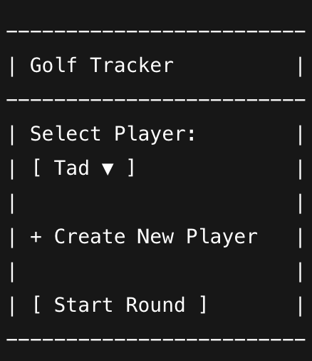
Mock Ups:

